SPARK User Manual
(Version V 1.0.0)
Whilst all reasonable care has been taken to ensure that the details are true and not misleading at the time of publication, no liability whatsoever is assumed by Automature LLC, or any supplier of Automature LLC, with respect to the accuracy or any use of the information provided herein.
Any license, delivery and support of software require entering into separate agreements with Automature LLC.
This document may contain confidential information and may not be modified or reproduced, in whole or in part, or transmitted in any form to any third party, without the written approval from Automature LLC.
Copyright © 2012 Automature LLC
All rights reserved.

Revision History
Version | Date | Name | Description of Changes
1.0 | 2010-09-23 | Nitish Rawat | First Edition
1.1 | 2010-11-04 | Nitish Rawat | Revised Edition with illustrative snapshot and new chapters
1.2 | 2010-11-09 | Nitish Rawat | Changes in section ordering
2.2.2 | 2011-08-30 | Sankha Sil | Changes in Atom path, new Option and Features
2.3 | 2011-09-16 | Sankha Sil | Changes in Relative Path and Command Line Macro Value Passing
3.0 | 2012-01-09 | Sankha Sil | New Feature added. Zug uses methods which are dynamically loaded
3.2 | 2012-03-25 | Sankha Sil | New Feature added Zug have Configuration Management for MVM
4.0 | 2012-03-29 | Sankha Sil | New Feature added Zug Reports Results uisng Davos
4.3 | 12-06-12 | Dipayan Sengupta | New Features : BuildTag and TestPlan added
4.4 | 20-06-12 | Dipayan Sengupta | New Feature :TopologySet
5.6 | 02-01-13 | Md Sarfaraz Khan | Added a trouble shooting , JRE dependence
5.7 | 22-01-13 | Sankha Sil | Added a new switch logfilename.
6.2 | 28-03-13 | Md Sarfaraz Khan | Added new module Reporting in testlink
6.3 | 20-05-13 | Md Sarfaraz Khan | Added command line options (-ignore,-atomexectime) and DB and script location configurations
7.2 | 28-04-14 | Chayan Hazra | Added adapter-param tag in ZugINI.xml to provide optional parameters to adapters.
1.0 | 28-08-14 | Md Sarfaraz Khan | SPARK documentation
Contents
Table of Contents
SPARK User Manual
(Version V 1.0.0) 1
Revision History 2
Contents 3
1. Introduction 5

1.1 Document Purpose 5

1.2 Intended Audience 5
2. Concepts and Terminologies 6

2.1 Test Suite 6

2.2 Test Case 6

2.3 Atom 6

2.4 Molecule 6

2.5 Action 6

2.6 Test Plan 6

2.7 Test Step 6

2.8 Verification Step 7

2.9 MVM Configuration 7
3. ZUG Options 8

3.1 -TestCaseID=Test001,... 8

3.2 -Repeat | -NoRepeat 8

3.3 -Autorecover | -NoAutorecover 8

3.4 -Verbose | NoVerbose 8

3.5 -Debug | NoDebug 9

3.6 -Verify | -NoVerify 9

3.7 -AtomPath=<location> 9

3.8 -Include=<location> 9

3.9 -Execute | -NoExecute 9

3.10 -$<macroname>=<value> 9

3.11 -TestCycleID=<integer> 10

3.12 -TestPlan=<Product:Release:Sprint:TestPlan> 10

3.13 -TestPlanID=<integer> 10

3.14 -TopologySetID=<integer> 10

3.15 -TopologySet=<AlphaNumeric> 10

3.16 -BuildTag=<AlphaNumeric> 10

3.17 -LogFileName=<AlphaNumeric> 10

3.18 -macrocolumn=<file identifier:column value> 11

3.19 -macrofile=<file location> 11

3.20 -ignore 11

3.21 -atomexectime 11
4 ZUG Modes 12

4.1 Production Mode 12

4.2 Developer Mode 12

4.3 Performance Mode 12
5 Process Flow 14

5.1 Architecture overview 14
6 Running your first automated test 15

6.1 Preparing Zermatt for Zug 15

6.2 Managing Atoms 15

6.3 Preparing Zug for Zermatt 16

6.4 Executing the automated test 17

6.5 Viewing results in Zermatt 22

6.6 Interpreting the results 22

6.7 Archival the Log files 25
7. Reporting 26

7.1 Reporting to TestLink 26

7.1.1 Basic Terminologies of TestLink 26

7.1.2 Preparing ZUG for TestLink 26

7.1.3 Preparing TestLink For ZUG: 27

7.1.4 Executing the automated tests 30

7.2 Reporting to Jira 32

7.2.1 Preparing ZUG for Jira 32

7.2.4 Executing the automated tests 32
8. Implicit Molecule Calls 33

8.1 ZCase_Verify 33

8.2 ZStep_Verify 33

8.3 ZEnv_Sensor 33
9. Troubleshooting 35

9.1 Debug Log 35

9.2 Primitive log 35

9.3 Database connection problem 35

9.4 Unable to Archive Log Files 36

9.5 License Expired 36
10 ZugINI.xml 38

10.1 Inprocess atoms configuration 38

10.2 DB Configuration and Script Locations 39
11 GUI and Debugger 41

11.1 Start Up Overview 41

11.2 Running a Test Suite 41

11.3 Choosing Environment 43

11.4 Debugging and break points 43

11.4.1 Break Points and test control 43

11.4.2 Break Points and variables 44

11.4.3 Expression Evaluator 45

11.5 Sheet View 48

11.6 Navigating sheets : 49

11.6.1 Navigating Molecules : 49

11.6.2 Navigating Different Sheets 49

11.7 Editing and Saving sheets 49

11.7.1 Editing Sheet 49

11.7.2 Saving sheet 50
12 Troubles hooting. 52

. Introduction
Zug is Automature’s software test automation tool. Zug provides an execution environment for tests specified using a high level test specification language namely CHUR. Zug is platform independent, and can be used on any environment that supports the Java Runtime Environment.

1.1 Document Purpose
The user manual explains you operation of Zug options. You will be able to use several options for customizing the execution of test cases.

1.2 Intended Audience
The user manual is intended for users who want to learn or run execution of test suites. Test suites are written in Chur. The test suite file is given as input to Zug.

. Concepts and Terminologies

2.1 Test Suite
As explained before Test Cases are individual programs designed to test a feature of a product. As there are usually hundreds or thousands of features in a single application, therefore the number of Test Cases would be equally high. To manage so many of them, Test Cases are grouped into Test Suites.

2.2 Test Case
A Test Case is a program whose purpose is to test a certain feature of a product. It tells the developer (or whoever else is trying to make the product work) whether the feature is working properly by verifying the results and if not, help them identify the cause of the malfunction.
The Automature Framework has a hierarchical structure in which Test Cases are at the core of it.

2.3 Atom
Atoms are the smallest unit of action in Chur. They are entities, such as programs or scripts that can be executed at the command line level in a shell (e.g. the Command Prompt in Windows). Atoms can be invoked on the Test Cases or Molecules worksheets in the Test Suite spread sheet on a single line. An example of an atom can be a program that enters text into a form field inside a web page, or can simulate a button click.

2.4 Molecule
Molecules are a collection of atoms in a sequence, with the added ability to express more complex logic. Molecules may call atoms directly, or through other nested molecules. Test Cases, themselves could be considered Molecules themselves, except that no other test case or molecule can call them. Example of a molecule can be to simulate a user login, by using the atom examples above.

2.5 Action
A test case is a sequence of one or more Actions. Each Action may take as many arguments as necessary. An Action atom is expected to return an exit status code that implicitly tells Zug if the action was successful. By convention a non-zero status is interpreted as a failure. When Zug encounters a failure status it automatically invokes the appropriate clean up steps.

2.6 Test Plan
Test plan is the comprehensive planning of how features can be tested with the respective test cases in certain topology sets. Each test plan may contain one or more test cycles which may be executed during the course of a certain phase of the product.

2.7 Test Step
A Test Step should be specified for each Action of a test case or a Molecule but not for a Verification Step. It should be monotonically increasing number for each test case action. If two steps of a test case have the same steps, then the two steps are executable concurrently. Some of these steps can be considered as initialization steps, few others the action steps and the rest as cleanup steps.

2.8 Verification Step
Each Action of a Test Case may consist of none, or several Verification methods. And each Verification method may take several arguments as needed. A verification atom is expected to return an exit status code that implicitly tells Zug if the verification was successful. By convention, a non-zero status code is interpreted as a failure. When Zug encounters a failure status in verification, it automatically invokes the corresponding clean up steps.

2.9 MVM Configuration
While running any testcase if it contains more than a certain level of multivalued macro it may fail due to java jvm max memory which is not sufficient for keeping that many Cartesian producted testcases. Due to low machine configuration it fails but it can run in high configuration machines. As so from Zug3.2 version this configuration dependency is introduced in ZugINI.xml as <configuations> tag. Under that tag there is another type tag <mvm-configurationjvm-max-memorysize="853">. This name attribute of this tag mainly identifies the machine JVM memory configuration, which helps to find out what is the JVM max memory it can avail. Under the tags the mvm cardinality is defined which have the number of cardinality of testcases. Cardinality: the total testcases generated by Zug doing Cartesian /indexed expansion over the number of MVMs in the testcase.

Below is a example of a configurations tags in ZugINI.xml.
<configurations>
<mvm-configuration jvm-max-memorysize="853">4000</mvm-configuration>
<mvm-configuration jvm-max-memorysize="455">3000</mvm-configuration>
<mvm-configuration jvm-max-memorysize="247">2500</mvm-configuration>
<mvm-configuration jvm-max-memorysize="122">1500</mvm-configuration>
</configurations>

. ZUG Options
Zug has a set of standard options that are supported in the execution test environment. The syntax the launching Zug is as follows:
RunZUG.bat [options] FILE.xls

3.1 -TestCaseID=Test001,...
If -TestCaseID is specified, Zug will execute only specific test cases as listed and will ignore the rest. The value to be specified is comma separated list of Automated Test Case Ids. This option is not required. By default all test cases specified in the input file are executed.

3.2 -Repeat | -NoRepeat
The -Repeat option allows the user to run a selection of test cases repeatedly, for a specified duration, or a specified number of iterations. The Longevity tests run the test plan setup and cleanup only once, and record a single result as the outcome.
Note: Zug debug logs are turned OFF during LONGEVITY MODE to ensure Zug does not consume too much disk space. By default, -NoRepeat is selected.
-Count=integer
This option specifies number of times the test cases mentioned in the test plan will be executed in iteration. This should be a number.
Example: -Repeat -Count=5
-Duration=time
This option specifies how long the test cases mentioned in the test suite will be iterated through.
The time value has to specified in
- [days]d
- [hours]h
- [minutes]m
- [seconds]s
Example: -Repeat -Duration=3d
Note: -Duration and -Count are mutually exclusive. If both of them are specified on the command prompt, then -Count takes precedence over -Duration.

3.3 -Autorecover | -NoAutorecover
The option -Autorecover specifies Zug to run cleanup during test plan/test step timeout or failure. By default, -Autorecover will be selected unless specified otherwise. If -NoAutorecover is specified, then there are no cleanup steps to execute.

3.4 -Verbose | NoVerbose
The option -Verbose is used to display debug messages on the output console. By default -NoVerbose will be selected unless explicitly mentioned. The option -NoVerbose does not display any debug messages on the output console.

3.5 -Debug | NoDebug
The -Debug option is specified to run the Automation in Debug Mode. In this case if any atom is not implemented then the Zug will prompt with a default atom. By default -NoDebug will be selected unless explicitly disabled.

3.6 -Verify | -NoVerify
The option -Verify specifies Zug to execute the testcase without verification. By default, -Verify is selected means ZUG will run verification actions for each testcase unless explicitly -NoVerify is specified.

3.7 -AtomPath=<location>
This option specifies the location from where ZUG will pick up atoms for Test Automation/Execution. This should be a fully qualified location and should not be a relative path. We can give multiple locations by ; separator.
Example: -Atompath=C:\Tests\Atoms

3.8 -Include=<location>
This option specifies the location from where ZUG will pick up molecules and macros for Test Automation/Execution. The location can be a file name residing in the same directory of that of the test suite or fully qualified location of the file but it should not be a relative path. We can give multiple locations by comma separator.
Example: -include=C:\Tests\Molecules
One more powerful feature of this option is to provide name spaces to the test suite included from command line. The syntax for giving name space in the -include option is
-include=namespace1#filename1,namespace2#filename2
In the test suite when we are using the macros and molecules of the included test suite then we should append the name space. For example if we are using a macro say $test of filename1 then in the main test suite we should write $namespace1.test.

3.9 -Execute | -NoExecute
-NoExecute mode will verify if the Test Design Excel sheet prepared by the user is syntactically correct or not. By default -Execute mode is selected unless explicitly specified. If -NoExecute is selected, Zug will just validate the test suite design sheet, display a list of errors, and exit without executing any test cases in the test suite.

3.10 -$<macroname>=<value>
-$$<macroname>={<value1>,<value2>}
This option specifies the macro value of the macro in the chur sheet. If the macro name is not written in the macro sheet of the chur spread sheet then it will add one while it is passed in the command line. The macro name should not contain any blank space and the macro value should not contain any blanks also. The macro value should be normally passed without giving any “”(quotes). Multi valued macro is also can be passed by providing the braces({}). It is also possible in providing of macro value as {1..2} for extended macro values.

3.11 -TestCycleID=<integer>
Use Zermatt to look for TestCycleID. If it is not provided then Zug will generate a new ID and update the results under it. By default, Zug always generates a new testcycle in ZERMATT unless explicitly specified to use an existing TestCycleID. TestCycleID can be found in ZERMATT page navigating to Test Cycle Report.
TestCycleID

Example: -TestCycleID=72

3.12 -TestPlan=<Product:Release:Sprint:TestPlan>
This is required to upload test case execution results in Zermatt under a particular Test Plan. Instead of using the testplanid, you can also report to Zermatt by naming the testplan in the following way:
Example: -TestPlan="ZUG:First Release:rc7 sprint:Smoke test plan"

3.13 -TestPlanID=<integer>
This is required to upload test case execution results in Zermatt under a particular Test Plan. Instead of using the testplan, you can also report to Zermatt by putting the testplanid in the following way:
Example: -TestPlanID=84

3.14 -TopologySetID=<integer>
This is required by Zug to register results in a testcycle for the specified Topology Set. The Topology Set has to be written in Zermatt and its id is to be specified. The Topology Set Id can be seen in the Zermatt page as shown below in the status bar of List all Topology Sets for a chosen Test Plan:
TOPOLOGYSET_ID
Example: -TopologySetId=26

3.15 -TopologySet=<AlphaNumeric>
Instead of using the topologysetid, Zug can register results in a testcycle by specifying the name of the topologyset. The topologyset set associated with the test cycle should be stated while running zug.
Example: -topologyset="First TopologySet"

3.16 -BuildTag=<AlphaNumeric>
This is required by Zug to upload the name of the Build in Zermatt for a particular sprint. You can report to Zermatt by naming the BuildTag in the following way:
Example: -BuildTag=Build074

3.17 -LogFileName=<AlphaNumeric>
This is required by Zug to change the logfile names where zug logs the execution messages(error,debug). The logfile name will be created as <logfilename>-Atom.log , <logfilename>-Debug.log.

3.18 -macrocolumn=<file identifier:column value>
We can have multiple value column in a test suite for a macro. This option let us select a particular macro value column for a test suite. The syntax for -macrocolumn is
-macrocolumn=file identifier:column number/name, file identifier:column number/name
The file identifier is the file name,default name space or the optional name space provided in the -include option. We can provide column number or the name of the macro column .If we have provided any optional name space in the -include option then it should be the file identifier in the -macrocolumn. If any cell of the selected column is empty then it takes the value of the default column cell(1st column i.e, the “value” column).

3.19 -macrofile=<file location>
This option is used to include a macro text file from command line. The text file contains macro in the format $macro=value. Each macro should begin in a new line. At run time ZUG treats these macros as it belongs to the main test suite. The syntax is -macrofile=filelocation .
Example: - macrofile=D:\Files\macroFile.txt

3.20 -ignore
This command line feature act as an overview mode. As the name suggests ZUG ignores all the errors that occur during the execution of test steps. If a test step of a Test Case or of a Molecule fails ZUG shows the error message but does not stop the execution and all the test steps of the test cases and that of the Molecules are executed.

3.21 -atomexectime
This command line feature is used to measure the performance of the atoms that are invoked from the test suite. After executing each atom ZUG appends the time taken to execute the atom in the end of the success message of the atom and at the end of the execution ZUG reports the min,avg, max execution time of the 10 most time consuming atoms in milli seconds. Given below is a sample output format for this command line switch.
[TC001] Execution Started Action Zbrowser.GoToURL with values [148283,http://www.google.com]
[TC001] Action ZBROWSER.GOTOURL SUCCESSFULLY Executed in 3023 milli sec.
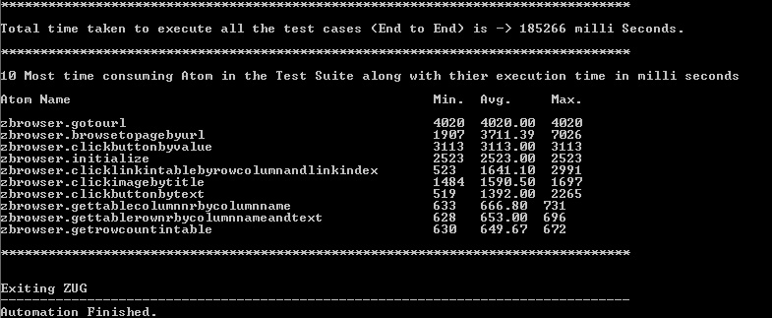

ZUG Modes

4.1 Production Mode
In production mode the tests are run and result are registered in Zermatt. This is done for unattended testing.
The following options are primarily used to design in this mode:
- -NoRepeat
- -AutoRecover
- -NoVerbose
- -Verify
- -Execute
- -TestCycleID=[integer]
- -TestPlanID=[integer]
- -TestPlan=[String:String]
- -TopologySetID=[integer]
- -TopologySet=[String]
- -BuildTag=[String]
The above options are discussed in detailed in Chapter 3: . ZUG Options.

4.2 Developer Mode
In this mode Test Automation Developer can debug the automated scripts
The following options are primarily used to design in this mode:
- -Verbose
- -Debug
The above options are discussed in detailed in Chapter 3: . ZUG Options.

4.3 Performance Mode
This mode is done to stress and measure performance parameters, values and attributes.
The following options are primarily used to design in this mode:
- -Repeat
- -NoVerify
- -Execute
- -TestPlanID=[integer]
- -TopologySetID=[integer]
The above options are discussed in detailed in Chapter 3: . ZUG Options.

Process Flow

5.1 Architecture overview

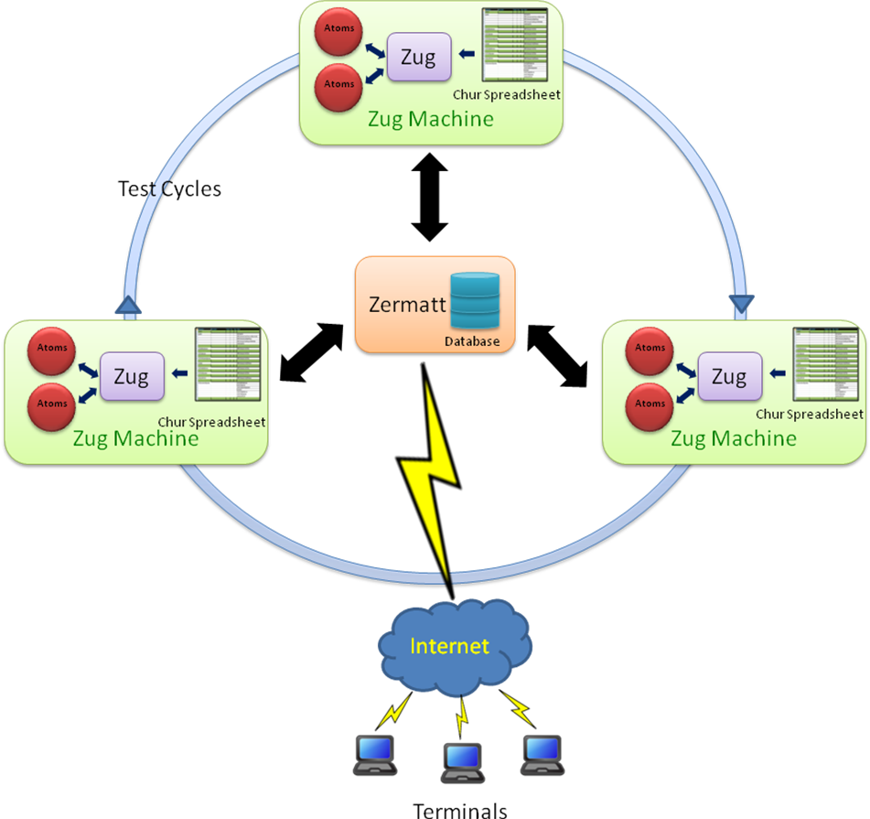

The atoms written in any scripting language are executed in Zug platform with the help of Chur spread sheet in different Zug machines. After execution the results are stored in the data repository of Zermatt. The end-users can access the results in Zermatt through the internet at real time.

Running your first automated test

In this manual we are using an example for illustration where we open a document using an office application and close it automatically.
(If you are not using Zermatt, then kindly ignore the following sections 6.1)

6.1 Preparing Zermatt for Zug

- Once the test plan is created in Zermatt, it can be used to store automated test results. The testplan_id of the test plan is one of the inputs required by Zug to file the results. The testplan_id can be found in Zermatt.

- The topology sets are also needed to be written in Zermatt for integration with Zug. The topology sets has to be added to the list of topology sets of the test plan. The topology set written should have at least one topology. The topologyset_id is found in the status bar of List all Topology Sets for a chosen Test Plan.

- We can see the participating topologies of the topology set in the Zermatt page List All Topology Sets:

- The role of any one topology as shown in the above figure should match with the role stated in the Chur spreadsheet that is to be written later.
(For deeper understanding on CHUR, please refer to the Language Reference Manual of Chur)

6.2 Managing Atoms
The atoms in Zug can be written in any scripting or programming language. In this manual we have created the atoms using AutoIT, a freeware BASIC-like scripting language designed for automating the Windows GUI and general scripting. For web based products, we have our own proprietary libraries named Zuoz. For more information regarding Zuoz kindly refer to www.automature.com.
The demo atoms are written in AutoIT and stored in a folder inside the Input files folder of the Zug Kit.

6.3 Preparing Zug for Zermatt
Once the atoms are written, the Chur spread sheet is prepared. For more information on how to write a Chur file please refer to the Language Reference Manual of Chur.
The figure below shows the configuration page of Chur file for this test.
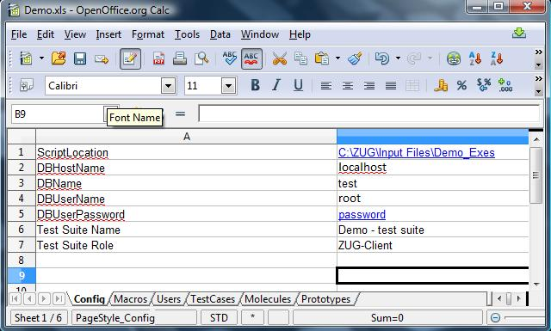

The Config page states the environmental information which is used by Zug to locate supporting programs and uploading results into the database.
- ScriptLocation states location of the folder where the Zug atoms are written for this test.
- DBHostName states the hostname for the database server. To keep the data repository of Zermatt in the Zug machine, localhost is given as input. We can provide the exact port number also for reporting.
- DBName states the database name.
- DBUserName states the name of the user to do authentication to database.
- DBUserPassword states the password of the user required for SQL authentication.
- Test Suite Name states the name of the test suite which was stated in Zermatt.
- Test Suite Role states the role of the node where Test Suite will be executed.
The figure below shows the macros page of Chur file for this test.

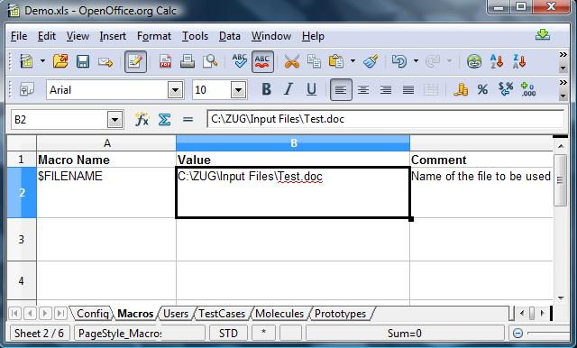
The macros allow the testcase designer to declare short names that can then be substituted in the testcase descriptions during execution. In this case, the path of the file Test.doc is given as input.

6.4 Executing the automated test

Time has come to execute the automated test in Zug. While executing, the test cycles will be incremented in Zermatt automatically. Before executing, the Zermatt page will look as shown in the figure below.

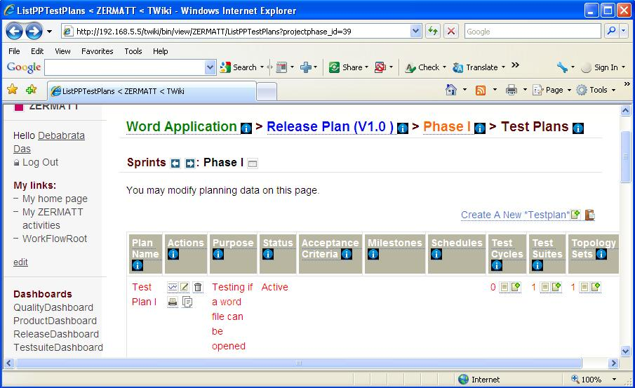
Topology Set associated with this test plan
- Open the command prompt.

- Type runzug "C:\ZUG\Input Files\Demo.xls" -testplanid=61 -topologysetid=1 –verbose

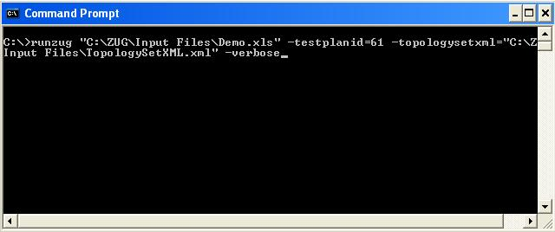

- The following screens will appear automatically. The automation starts....

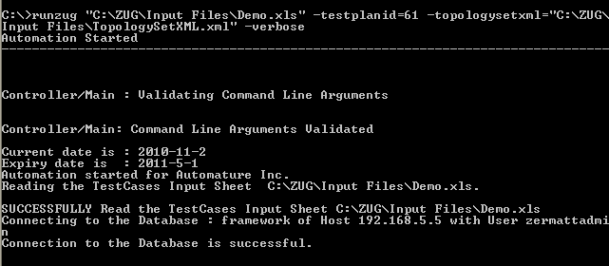

- The atom named STARTAPP.EXE is called to execute.
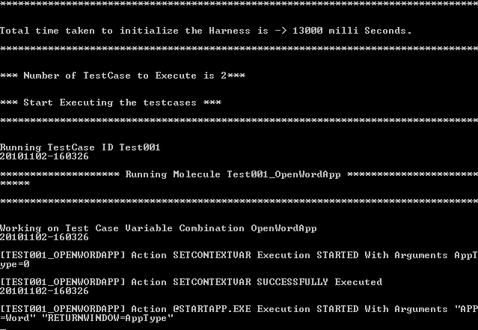

- The Word Application is opened.

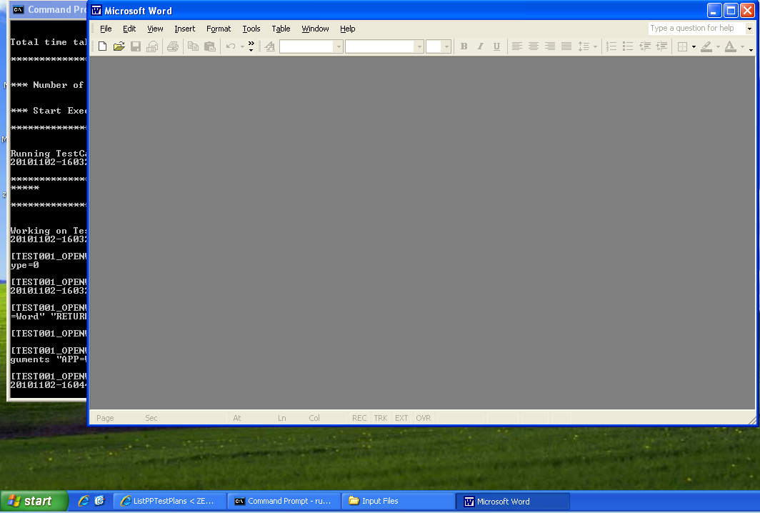

- The Word file is opened by executing the OPENFILE.EXE.

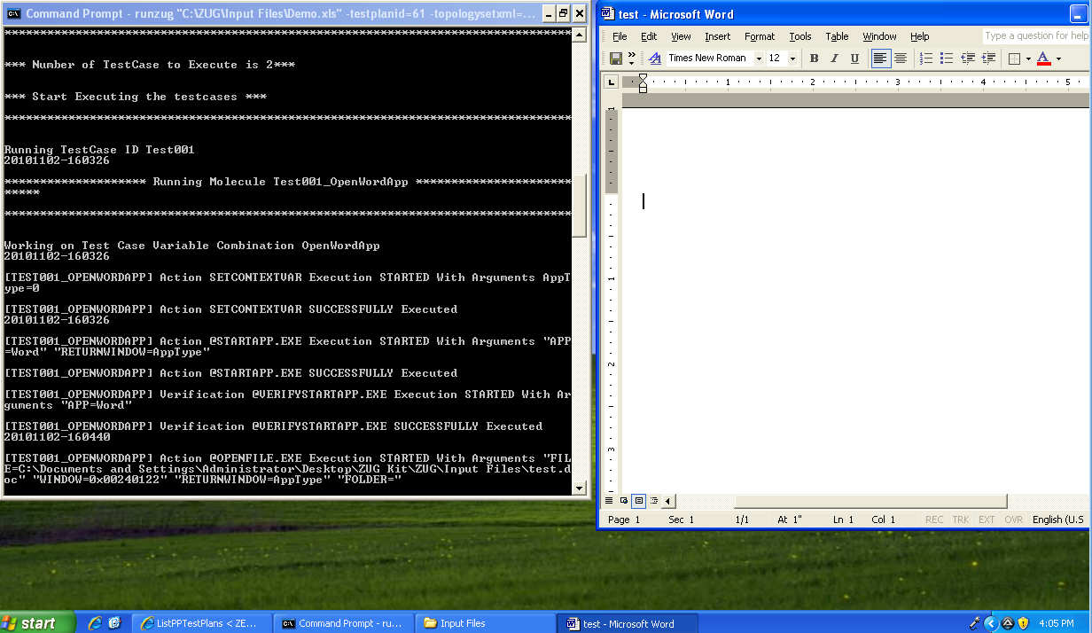

- After the Word file is opened, the CloseFile and the ExitFile executable files are called which closes the Word file and then exits from the Word application.

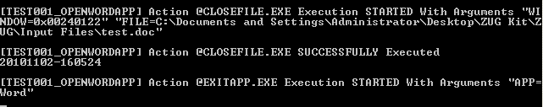

- The following screens appear on the command prompt which gives the result of the automated test.

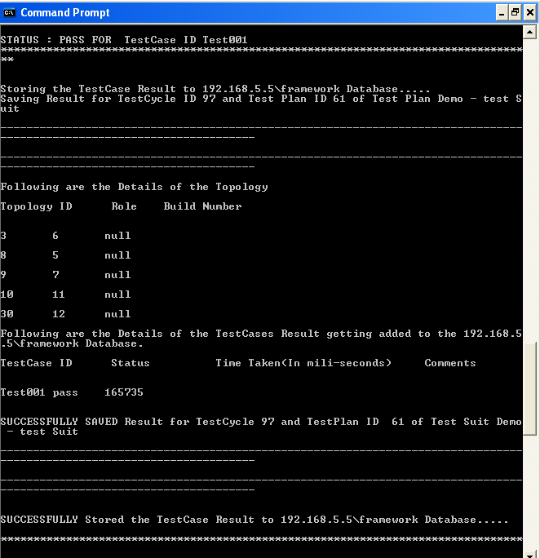

The detailed explanation will be stated in the following section 6.5-6.5 Viewing results in Zermatt.

6.5 Viewing results in Zermatt

- You will see that the test cycle is automatically increased to one. Refer to section Executing the automated test to see the previous value of test cycle. Now every time you run Zug, the value increments by itself.
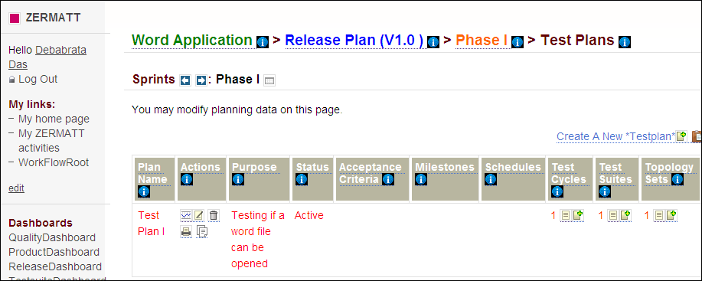

6.6 Interpreting the results
- Results in Command Prompt
The progress of the test-cases are displayed one after another. The specified Action and Verification Steps inside the test cases are executed and are shown at the same time in the command prompt. If any step fails then the exception message is displayed explaining the cause of failure.
At the end the brief result are shown in tabular form. The table has columns TestCase ID, status, Time Taken, Comments.
TestCase ID | The identifier of the test-cases which ran inside test suite
status | Pass/Fail
Time Taken (milli seconds) | Milliseconds taken to execute the test case
Comments | On failing, this states the exception message with the reason of failing

- Results in Log Files
Zug will generate four types of Logs. These logs will be created inside the AppData Folder (Application Data folder of windows OS) of logged in user.
All the Log File Name will be appended with a Date Time. For example Debug log will be named as 2008128-163637543-Debug.log (format is yyyymmdd-hhmmssmillisecond-debug) which means that this Debug Log is created on 8th December 2008 at 16 hours 36 minutes (last 5 are seconds and milli-seconds). Following is the description of the log files -
- "Result.log" - This log will contain the result of the test case, It will contain the status of the action(s) specified in the TestCase worksheet and also the appropriate error result if any error thrown during the test case series execution.
- "Debug.log"- This log will contain all the debug related messages.
- "Error.log"- This log will contain the error and warning messages if any error occurred during the execution.
- "Primitives.log" - This log will contain Logs from the Atoms during atom execution.

Viewing the test results from Zermatt:
To view the results in Zermatt, navigate to the page where the test plans are written. As said earlier, the test cycle is incremented from 0 to1.

View

Click on View and you will be able to see the following page. It states the time and the date of the initialization and completion of the test cycle.
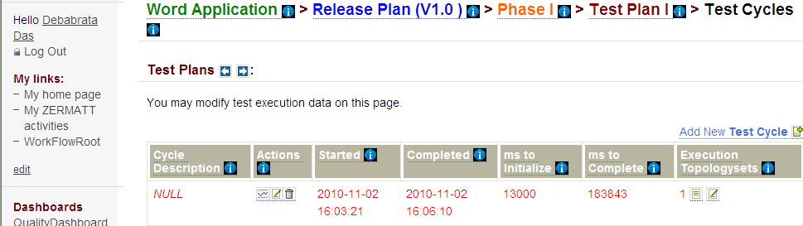

If you navigate into the topology set of that test plan, the test execution results are shown. It stated that the test has passed and also the duration and the date of the test execution.

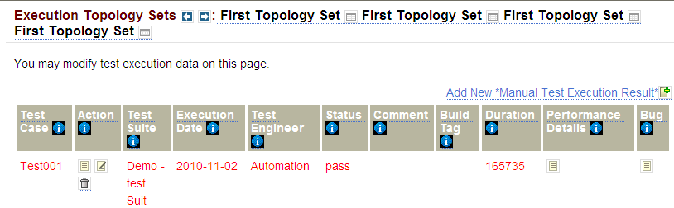

If you navigate to the Dashboards, the various kinds of results that might be possible is shown in various formats. For further information regarding dashboards, kindly refer to Zermatt User Manual.

6.7 Archival the Log files
Zug supports log archiving. If Zermatt integration is used then Zug will archive the log. Zug will archive two types of logs:
- Tested product (like LMDC Client, Server) log files. Log file specified in Config sheet of Test design sheet. This is done by specifying ProductLogLocations in the Config sheet of Chur Test Suite.
- Zug created log files (Debug, Error, Result).These are the log files which are generated by the Zug during test plan execution.

Log Archival Setup
You can specify Archive Location in the Zermatt Configuration Page:

. Reporting

7.1 Reporting to TestLink

7.1.1 Basic Terminologies of TestLink
Test Projects are the basic organizational unit of Test Link. Test Projects could be products or solutions of your company that may change their features and functionality over time but for the most part remain the same. A Test Project includes Test Specifications with Test Cases, Requirements and Keywords. Users within the project have defined roles. Test Projects are independent and do not share data.
Test Case describes a testing task via steps (actions, scenario) and expected results. The Test Case is the fundamental element of Test Link.
Test Suite organizes Test Cases into units. Each Test Suite consists of a title, a formatted description, Test Cases and possibly other Test Suites. TestLink uses a tree structure for Test Suites.
Test Plans are the basis for test execution activity. A test plan is created when you wish to execute Test Cases. A Test Plan contains name, description,collection of chosen Test Cases, Builds and some optional attributes (Test Results, milestones, tester assignment and priority definition). Each Test Plan is related to the current Test Project.

7.1.2 Preparing ZUG for TestLink
We need to provide some information in the configuration page of the Chur spread sheet in order to report the execution results of test cases in Test link.
The figure below shows the configuration page of Chur file for this test.

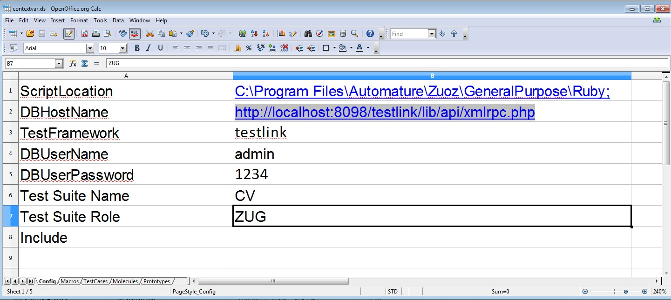
The Config page states the environmental information which is used by Zug to locate supporting
programs and uploading results into the Test Frame Work.
- ScriptLocation states location of the folder where the Zug atoms are written for this test.
- DBHostName states the host name for the Test framework server. Here we have to provide the the IP address along with the port number in which the server is listening and the rest of the part is the location of a PHP(xmlrpc.php) file in the Test Link framework.
- TestFramework states the name of the Test Frame Work in which we want to report the results of the test case execution. Since we want to report in TestLink the value of the field is testlink.
- DBUserName states the name of the user to do authentication to the Test Frame Work. In this case we are using the admin.
- DBUserPassword states the dev key ,also named as Personal API access key or script key for the user.
- Test Suite Name states the name of the test suite which was stated in Test Link.
- Test Suite Role states the name of the Test Project to which the Test Suite belong.
Note:The dev key,also called Personal API access key can be found in the MySetting link in TestLink. If the key is not generated then click on the button “Generate a new key”.A key will be generated. Below is the snapshot of the page.

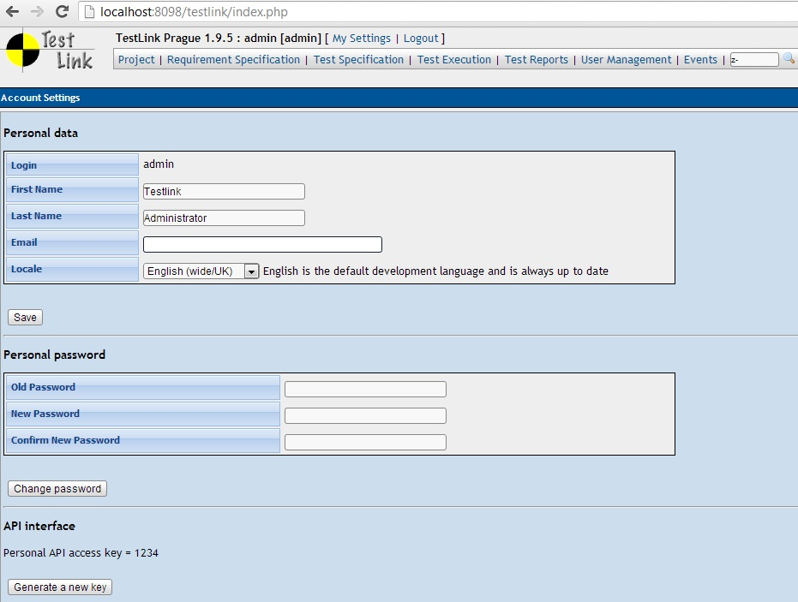
However if the last section of the page (API interface) is not there and there is no button for generating a new key then follow the subtopic “Enable API interface” in our next topic.

7.1.3 Preparing TestLink For ZUG:

- Create a Test Project and while creating a test project make sure that Enable Test Automation (API keys) box is checked. If the project is already created then click on the project and see if the check box is selected or not. If not then select the check option and save it.
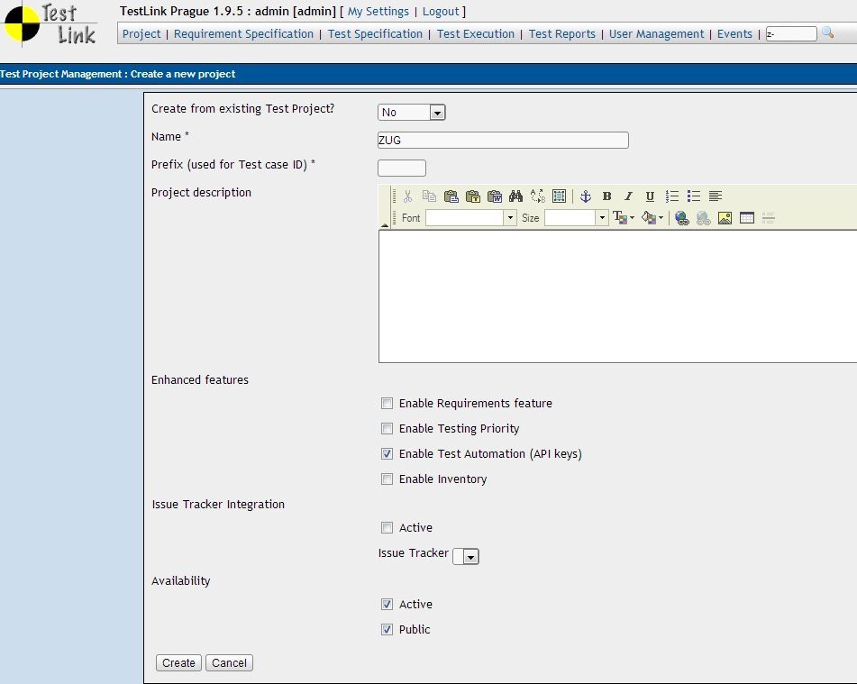
- Create a new Test Suite in the Test Project.
- Once the Test Suite is created we can add test cases in the Test Suite.
- We need to create a Test Plan and a build for that test plan.
- Finally once the Test Plan and the build is created the test cases need to be associated with the test plans.
Note: For reporting from ZUG in Test Link Test Project and Test Suite only needs to be created before running the tests. Last 3 steps mentioned above can also be performed by ZUG. However for that the user whose credentials is mentioned in the chur's configuration sheet must be authorized in test link to do the mentioned operations. For more information on TestLink read the user manual for test link( http://www.teamst.org/_tldoc/1.9/testlink_user_manual.pdf ).

Enabling the API Interface:
(This section if needed only if the API interface is disable and the user is not bale to generate API key)
By default the API Interface is not enabled in the TestLink. In the TestLink folder there is file config.inc.php.
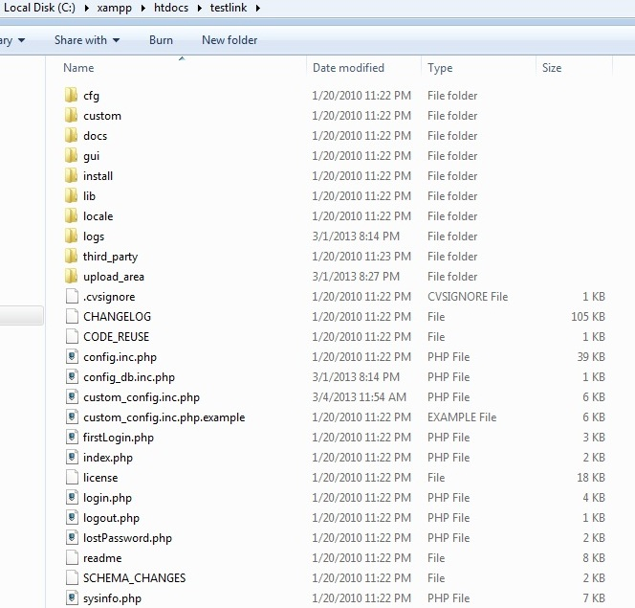

Open this file with any text editor and search for the line :
$tlCfg->api->enabled .If $tlCfg->api->enabled = FALSE;

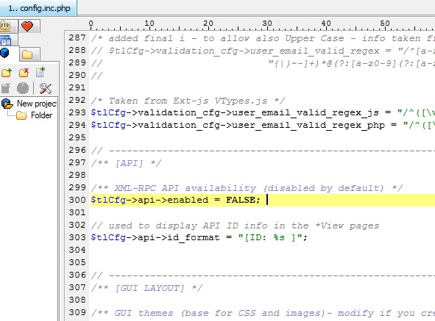

then set it to true by replacing the line with :
$tlCfg->api->enabled = TRUE;

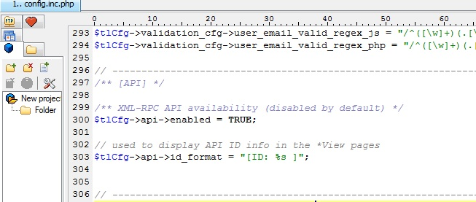
Now save the file and upload the folder to the server and start the server(If the server was already running then it should be stopped first and then needs to be restarted after the changes have been made).

7.1.4 Executing the automated tests
- Open a command prompt.
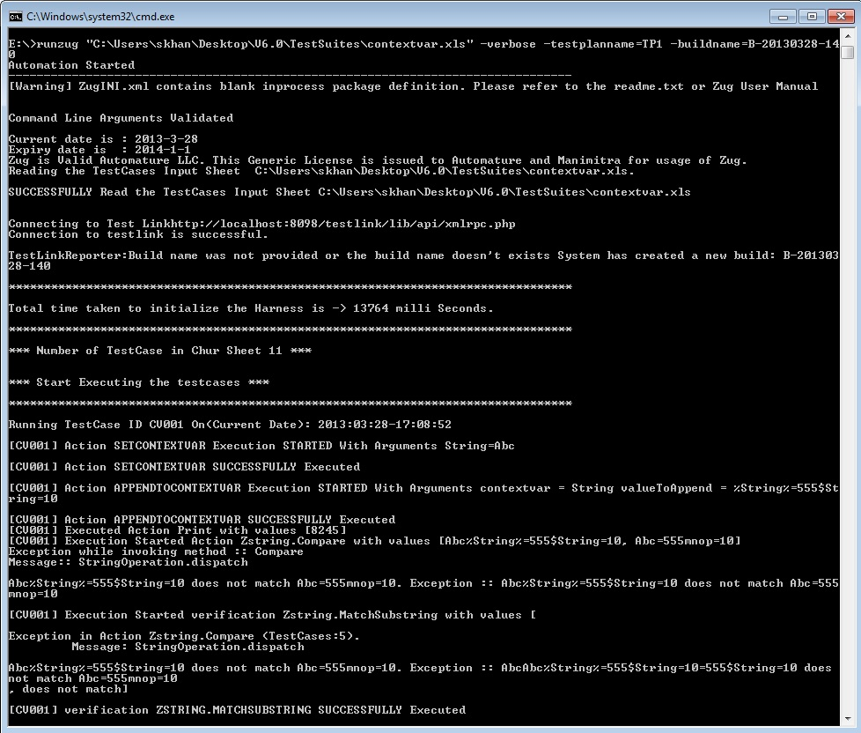
- Type runzug “file path\filename.xls” -verbose -testplanname= mytestplanname -buildname=mybuildname . For example
If the test plan name doesn't exists then it creates one with the mentioned test plan name and also creates a build with the mentioned build name. The build name is optional if we don't give a build name it will create a new build with a new system generated build name.
The following lines will appear automatically. The automation starts....
- Once the execution is finished we can go to the Execute Test cases link in the Test Link and select the test plan name and the build name that we mentioned in the command prompt in the runzug command.
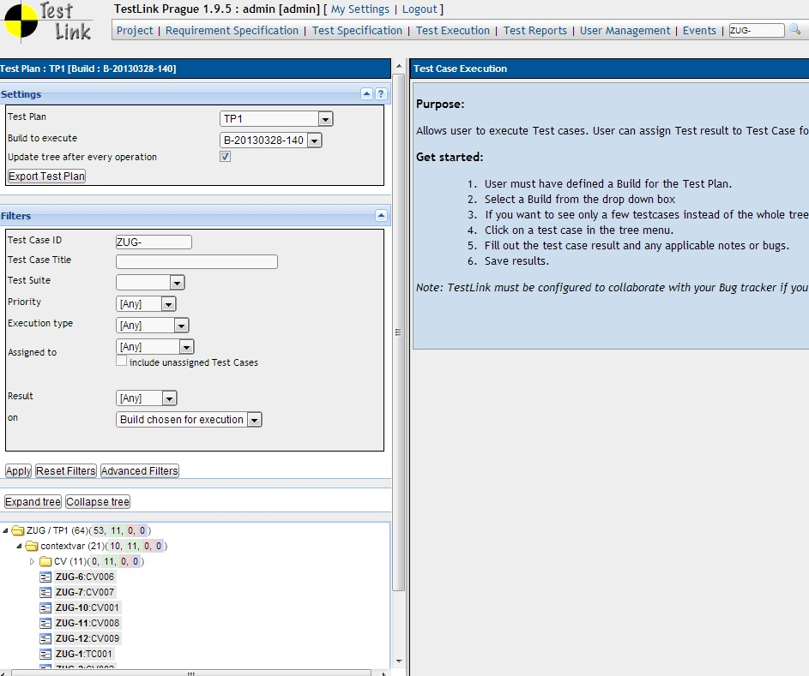
Test plan
Build

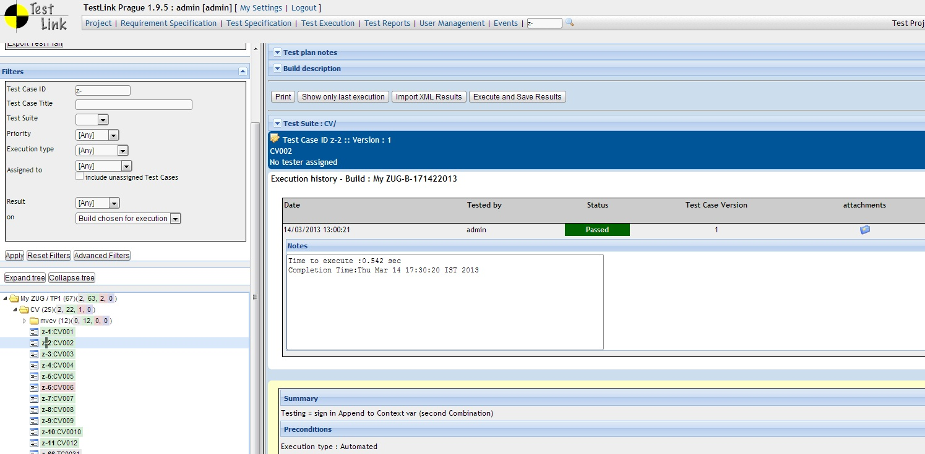
- Once we choose the test plan and the build we'll be able to see the executed test cases as shown in the above pic. To see the execution result of a test case click just click on it as shown below.

7.2 Reporting to Jira

7.2.1 Preparing ZUG for Jira
We need to provide some information in the configuration page of the Chur spread sheet in order to report the execution results of test cases in Jira.
The figure below shows the configuration page of Chur file for this test.
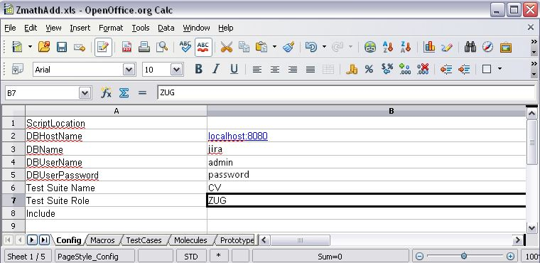

The Config page states the environmental information which is used by Zug to locate supporting
programs and uploading results into the Test Frame Work.
- ScriptLocation states location of the folder where the Zug atoms are written for this test.
- DBHostName states the host name for the Test framework server. Here we have to provide the the IP address along with the port number in which the server is listening.
- DBName states the name of the test framework.
- DBUserName states the name of the user to do authentication to the Test Frame Work. In this case we are using the admin.
- DBUserPassword states the user password
- Test Suite Name states the name of the test suite.
- Test Suite Role states the name of the Test Project to which the Test Suite belong.

7.2.4 Executing the automated tests

- Report to a particular cycle:
zug -verbose xyz.xls -testplan=ProjectKey:VersionName:TestcycleName -topologyset=mno -buildtag=anyName
- This will create a new testcycle everytime:
zug -verbose xyz.xls -testplan=ProjectKey:VersionName -topologyset=mno -buildtag=anything

. Implicit Molecule Calls
Often we would like to run some operations or some verification that are implicit in nature. For example sensing the environment on which the tests are being run or checking after each test case that the application that is being tested is reachable or running. For this purpose there are some molecule names that have been reserved. When a molecule is defined in the test suite with the reserved molecule name that molecule is called implicitly by ZUG.

8.1 ZCase_Verify
If a molecule of this name exists in the Molecule sheet then that molecule is implicitly invoked after the execution of each Test Case. We don't have to call this molecule explicitly ZUG Implicitly calls this molecule after running each of the Test Case. However this Molecule is not invoked for the Init and CleanUp test case.

8.2 ZStep_Verify
If a molecule of this name exists in the Molecule sheet then that molecule is implicitly invoked after the execution of each test step. The test step can be of a Molecule or that of a Test Case. ZUG Implicitly calls this molecule after running each of the test step. However this Molecule is not invoked for the test step of Init and CleanUp test case and also for the test steps of ZCase_Verify molecule.

8.3 ZEnv_Sensor
A molecule is defined with this name to sense the environment in which the tests are being run. This molecule is invoked implicitly after running the Init test case or after running the first test case of the test suite.

In the above pic we can see there is a test case and a molecule Zenv_Sensor. Also we have used a context variable ZEnv_Values .This context variable is defined by ZUG to store some environment related information. Initially it holds some values like OS Name=Windows 7,Java Version=1.6,User Name=Ellora ,etc as a comma separated list. We can further add some more details in the ZEnv_Values context variable in this molecule which may be needed. For example the name and the version of the browser that will be used for the browser operations.

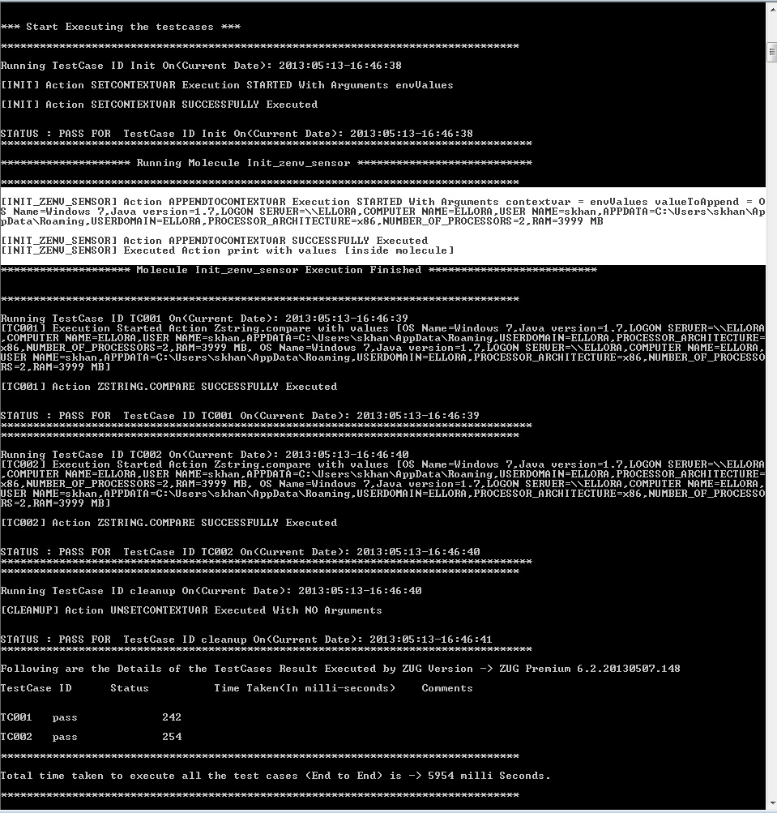
Above is the console output of the test case. We can see that in the console output that the Zenv_Sensor molecule have been implicitly invoked in the end of the Init test case.

9. Troubleshooting

9.1 Debug Log
Zug generates different log file. Debug file stores messages which contain extensive contextual information. They are mostly used for problem diagnosis. In failures this file can be referred back to diagnose and investigate problems, exception. The step-by-step execution messages are appended during Zug automation. The file can be browsed through and

9.2 Primitive log
Zug executes Atoms. To learn how to write Atom please refer to Automature's Zuoz Programmer's Guide. Inside Atoms some logging command mechanism can be used to help future diagnosis of Atom execution. The Atom Logs are stored in Primitive Log File. In failures this file can be referred back to diagnose and correct Atoms

9.3 Database connection problem
In order to integrate test results with Zermatt there should be establishment of proper database connection. You can allow access to certain machines for the specified user connection. Do database user administration to add and modify users permission. Put proper connection details in preparing Zug for Zermatt. Refer Page 16 6.3 Preparing Zug for Zermatt
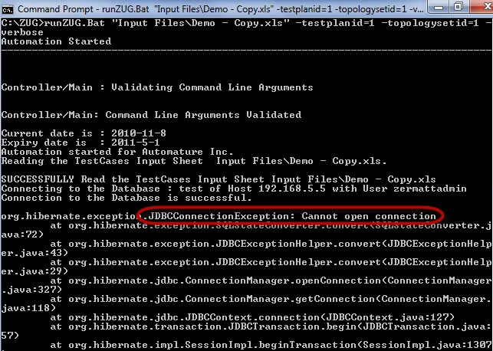

9.4 Unable to Archive Log Files
Archiving of Log files are done on location specified in Configuration (Refer page 25 6.7 Archival the Log files) Zug machine should be given proper write-permission for the location specified. An exception can occur as following:
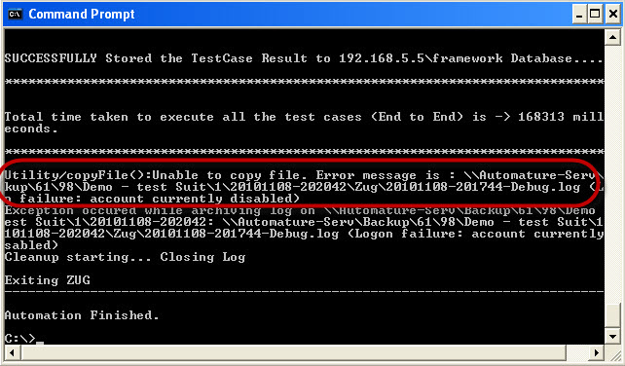

9.5 License Expired
License can expire under the two following cases
- You are using an expired license. Each license has a certain validity period and it expires on a particular date as mentioned.
- You are using an improper license. The license may be incorrect or intended for other use.

9.6 JRE Dependency
If the JRE is updated from java 1.6 to java 1.7 after installing ZUG then ZUG will stop working and it will give an error message similar to the message given below
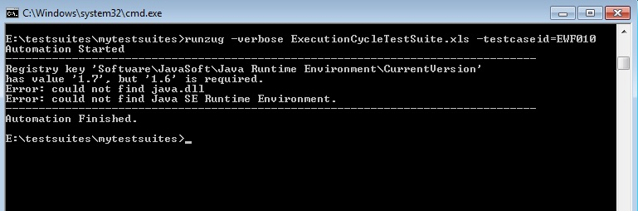
Solution: Reinstalling ZUG will fix the problem

10 ZugINI.xml

10.1 Inprocess atoms configuration

Zug3.0 version can call the external java jar files as built-in atoms through chur spreadsheet. To make this happen the ZugINI.xml parsing is needed. Inside the Zug installation directory, the ZugINI.xml file can be edited to by putting the values in the tags of
<inprocesspackages>
<inprocesspackage name="" language=””>
<file-path></file-path>
<jar-package></jar-package>
<class-name></class-name>
</inprocesspackage>
</inprocesspackages>
This xml file (ZugINI.xml) is in ZUG installation folder.
For any Java inprocess atoms, the inprocesspackage tag contains file-path,jar-package and class-name tags.
Example:
<inprocesspackages>
<inprocesspackage name="Zbrowser" language=”Java”>
<file-path>C:\Programfiles\Automature\ZUOZ\Builtins</file-path>
<jar-package>com.automature.zuoz.builtins.zbrowser</jar-package>
<class-name>BrowserOperations</class-name>
</inprocesspackage>
</inprocesspackages>
For any C++ dll atoms the same inprocesspackage tag will contain different tag values example -
the language tag will be changed to “JNI”. The file-path tag will specifies the dll. The dll-name tag specifies the name of DLL file.

Example:
<inprocesspackages>
<inprocesspackage name="JNIDLL" language=”JNI”>
<file-path>C:\Programfiles\Automature\ZUOZ\Builtins</file-path>
<dll-name>TestDLL</dll-name>
</inprocesspackage>
</inprocesspackages>

For any COM dll atoms the Program ID is needed.
For the same inprocesspackage tag, language attribute value will be “COM” and there will be one additional tag as prog-id.

Example:
<inprocesspackages>
<inprocesspackage name="ZCOM" language=”COM”>
<prog-id>Automature.Pioneer</prog-id>
</inprocesspackage>
</inprocesspackages>

10.2 DB Configuration and Script Locations

In the config sheet of the test suite we have to mention the script location and also some information of the Test Management Framework (credentials,host name,etc) for reporting the execution result of the test cases. However Test suites running on the same machine may report to the same Test Management Framework with a default data base credentials and also we may want to have a default repository for the out process atoms. Thus we can mention default script locations and default configuration for the Test Management Framework in ZugINI.xml file. In the ZugINI.xml file inside the configurations we can mention the default script locations under the script location tag and the Test Management Framework information in their respective tags as shown below
<configurations>
<scriptlocation>C:\ProgramFiles;C:\ProgramFiles (x86)</scriptlocation>
<dbhostname>http://localHost:4567</dbhostname>
<dbname>Framework</dbname>
<dbusername>davosuser</dbusername>
<dbuserpassword>user</dbuserpassword>
<adapter-param name="mno">xyz</adapter-param> **
</configurations>

**This tag can be used to provide optional parameters to adapters while reporting.
The default format for jira to generate custom issue summary is Testsuite:Testcase.
<adapter-param name="issueformat">$TS:$TC</adapter-param>
Other possible formats
<adapter-param name="issueformat">$TS-$TC</adapter-param>
<adapter-param name="issueformat">$TC</adapter-param>
<adapter-param name="issueformat">$TS&&$TC-testcase</adapter-param>
<adapter-param name="issueformat">TS:$TC</adapter-param>
<adapter-param name="issueformat">$TC-$TS</adapter-param>

$TC will be replaced by test case name and $TS will get replaced by test suite name. If $TC is missing in the tag value, then issue summary will take the default format.

For further problems visit ZUG Forum.

11 GUI and Debugger

11.1 Start Up Overview
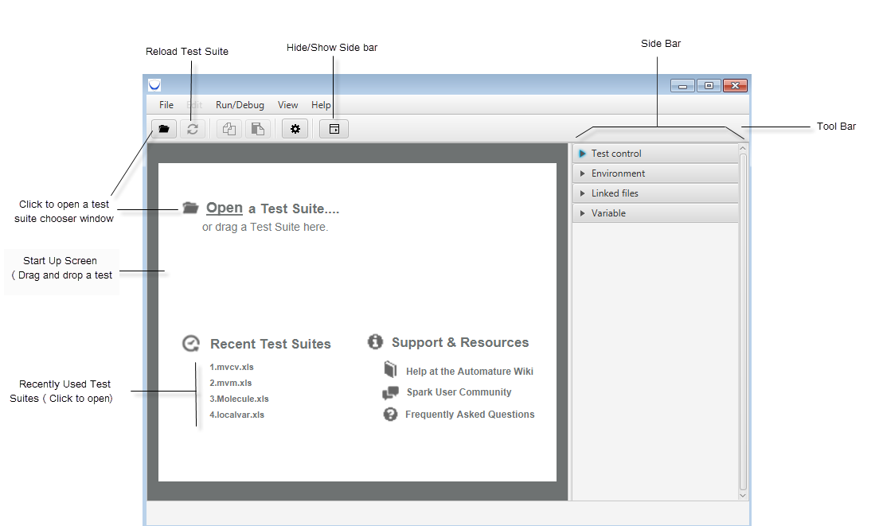

11.2 Running a Test Suite
Choose a test suite by clicking on the open button in the toolbar or using the menu options
File → Open or File->Open Recent
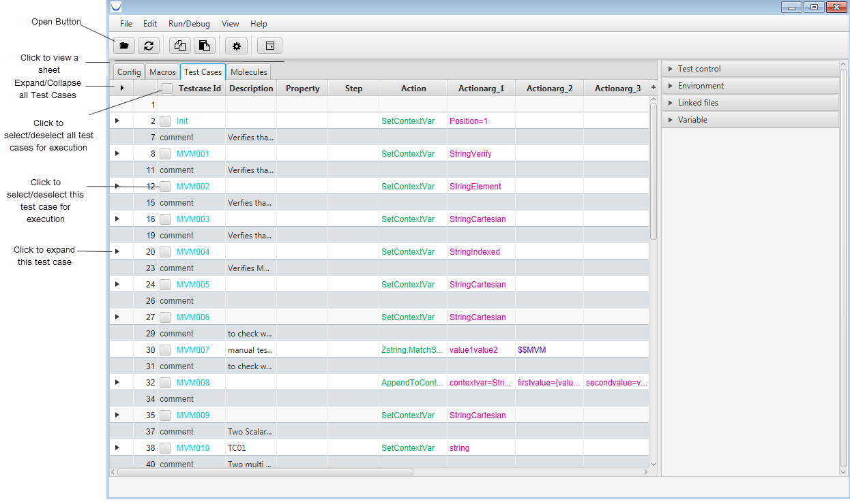

Sheet View

Select any test case or all test case by clicking on the check boxes as shown in the snap shot above.
Click on the Test Control in the Side bar. From here user can select the run time options for executing tests (to know more about options please refer section 3).Then click on the execute button to execute tests or you can also use menus the Run/Debug ->Run Tests.
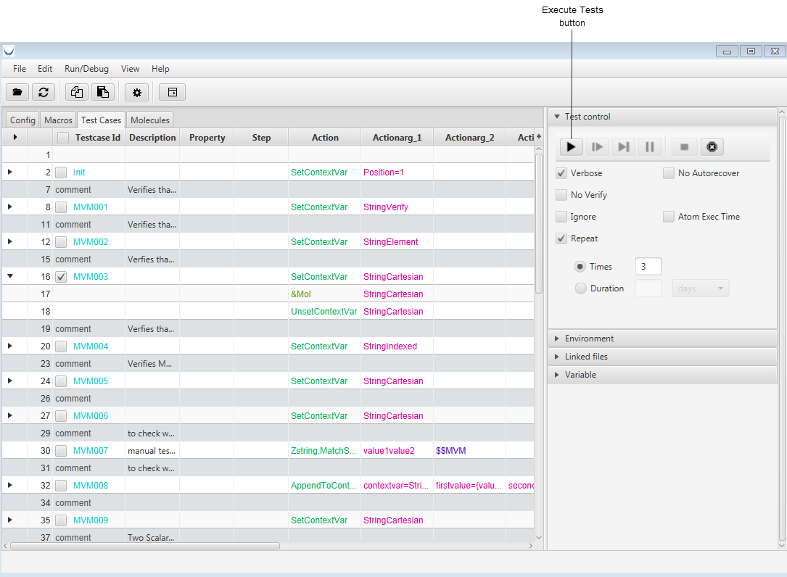

As soon as the test execution is started some run time options will be enabled as shown in the pic below. As the test proceeds the test steps that are executed or are currently executing are highlighted.
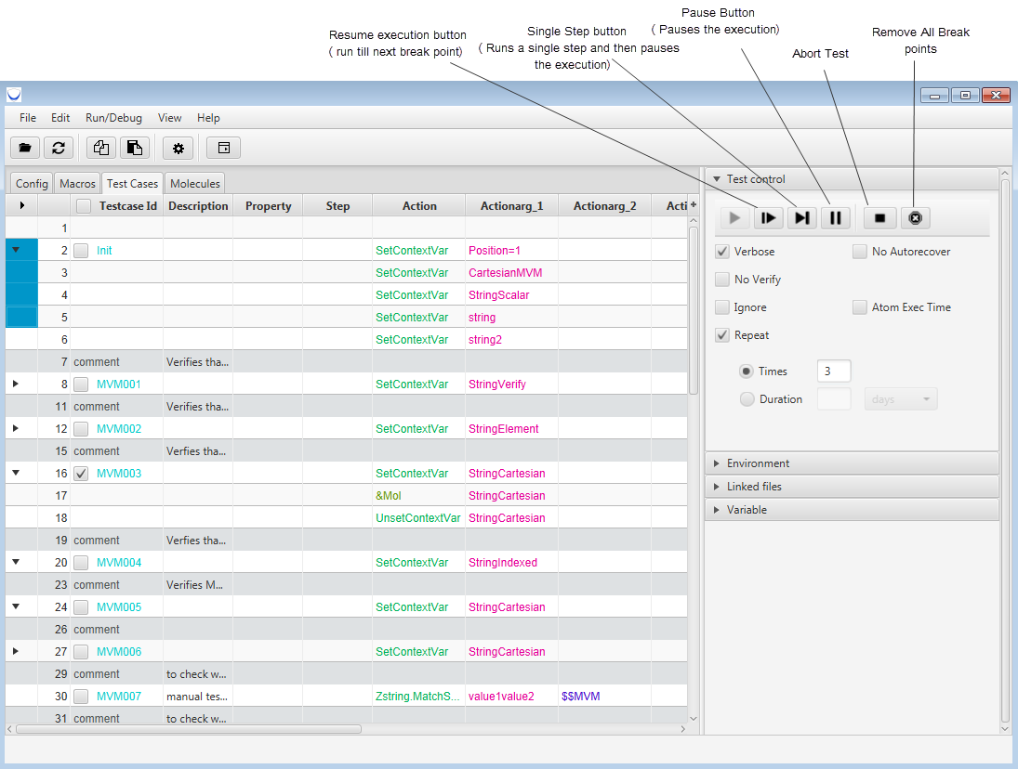

User can stop the test by clicking the abort button.

11.3 Choosing Environment
If the test suite is designed to run on a different environment using the Environment options in the side bar we can select a particular environment. Also if we want to over ride any environment value (macro value) we can provide in the Macros text field using this options as shown in the tooltip in the below picture.
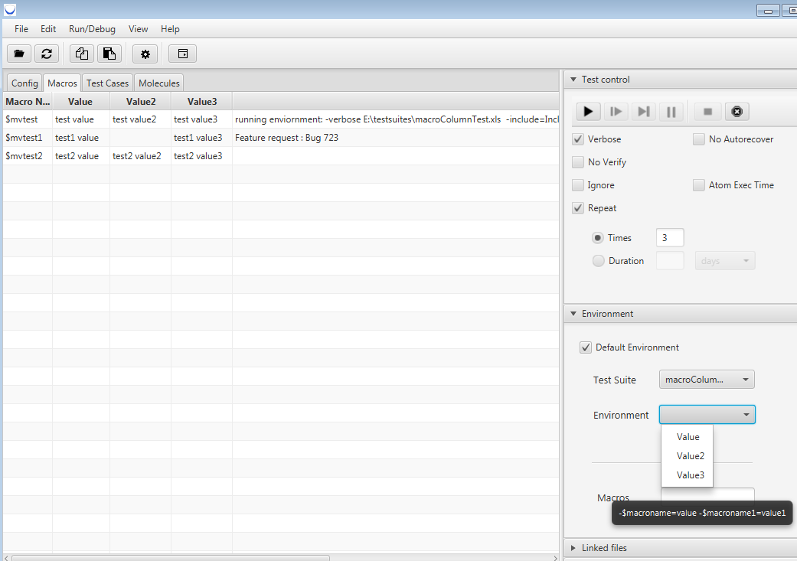

11.4 Debugging and break points

11.4.1 Break Points and test control
Spark comes with an built-in debugger. You can put break points before the execution of the test suite or at any time of the execution by simply clicking on the line number of molecule or test case tab in the sheet view. Now when the execution reaches that line number(break point) it will pause the execution before executing that step( as shown in the pic below). You can use the controls below shown in the pic to control the test execution i.e, execute each step at a time by using single step button,or resume the execution normally (or till next break point).Further if you have added more break points and you don't want to use them you can simply click on the remove all break point button.
At run time when the test suite is running at any instance you can pause the execution,add a break point or remove the break points and further you can keep a watch on the variables you want(discussed in the next topic).
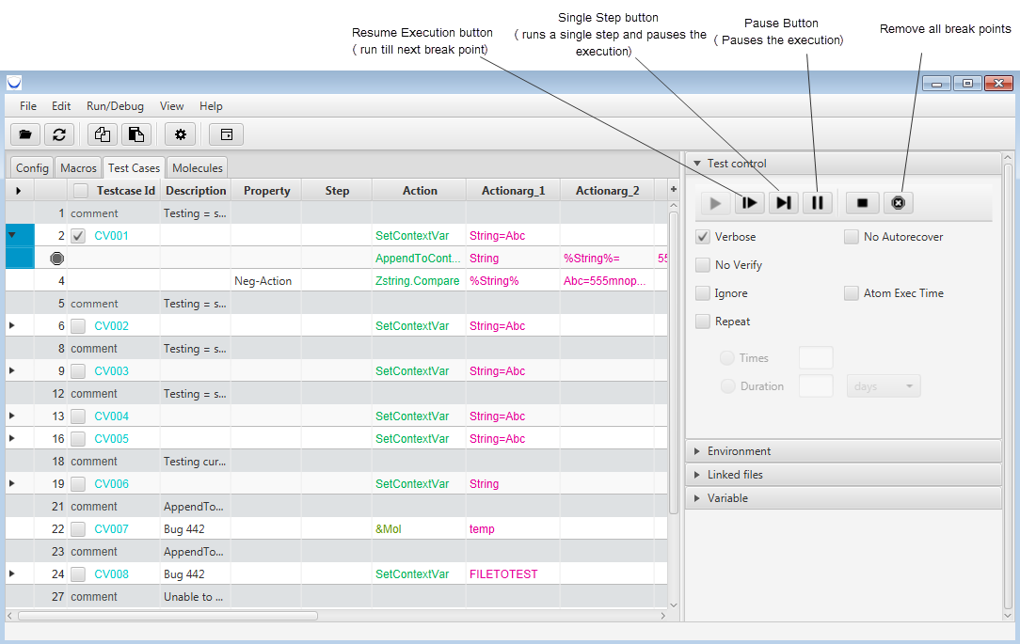

11.4.2 Break Points and variables
While developing or debugging test cases we want to keep a watch on certain variables and monitor their values at certain instance of the execution. For this Spark has a variable window in the side bar.
At run time or when the execution is paused (preferred) we can search for a variable using the search box in the variable window and add it to the watch list using the add button shown in the pic.
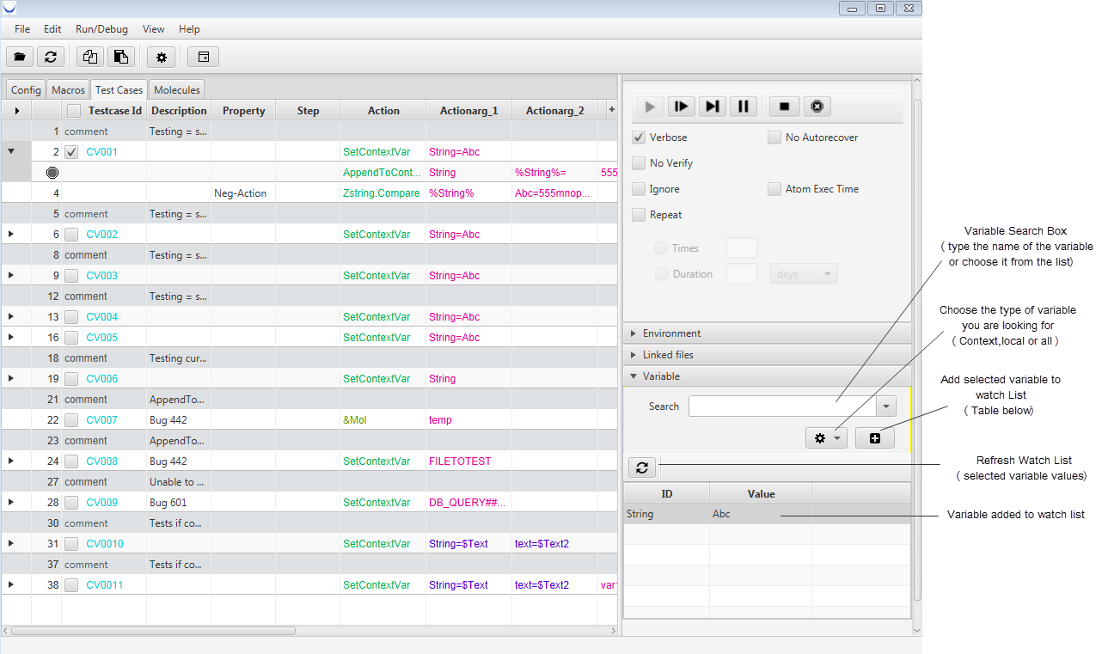
You can also choose the type of the variable to filter your result. In the watch List we can add up to 5 variables.
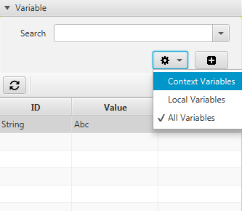

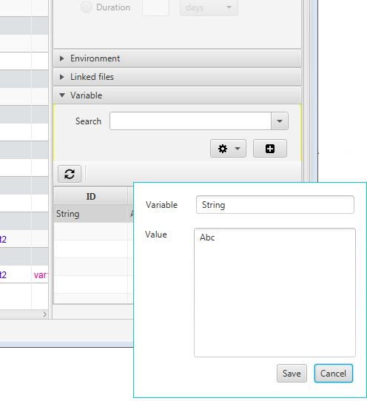
Editing Variables value:
Spark also provides the provision to edit the variable value added to the watch list. To edit a variable value just double click on the ID or Value column. A pop up will appear as shown
and you can edit the value of the variable and save it.

NOTE: If the variable is unset or removed
then on refreshing the list it will disappear from the watch list.

11.4.3 Expression Evaluator

This feature lets you run any atom(s) or molecule(s) seperately from the test cases.User can run any atom or molecule and the outcome of that does not affect the outcome of the test case.This feature gets activated only when the test suite is running.To run any atom of molecule pause the execution of the test suite running.This feature is extremely helpful while debugging or writing test cases for Browser realted testing.
Go to Run menu and click on the Expression Evaluator menu .
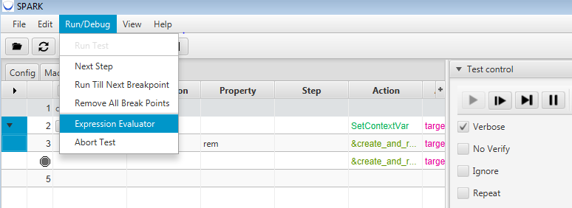

Expression Evaluator window will appear.
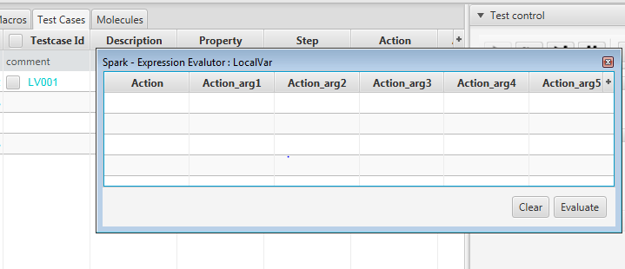

User can write the atom names and the arguments and click on the evaluate button.
It also comes with an autocomplete feature to help the user with atom and molecule names in the action column.When done editing a cell user must press ENTER key to commit the changes.
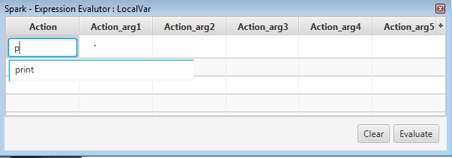

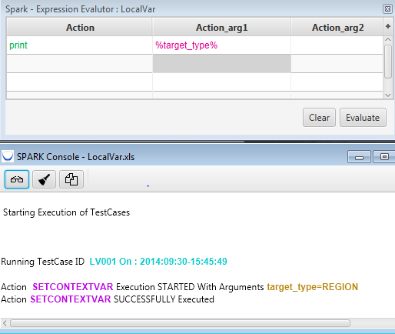

Click on the evaluate button and the result of execution will be available in the console.
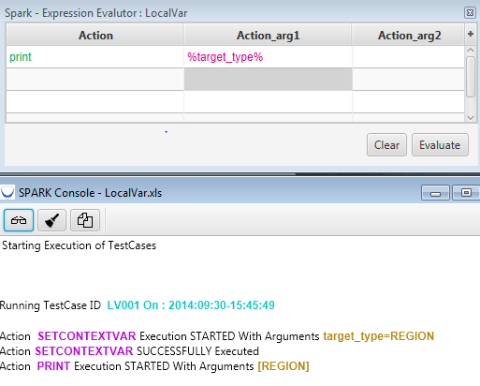

We can also call and execute molecules from Expression Evaluator.
NOTE : The namespace of the expression evaluator is the namespace of the currently open spread sheet in sheet view .Currrently Expresssion evaluator does not support local variable.
Increasing the number of columns.
Click on the plus sign and select the number of arguments column needed as per requirement.

Clearing the Expression Evaluator Sheet
Click on the clear button to clear the Expression Evaluator sheet.

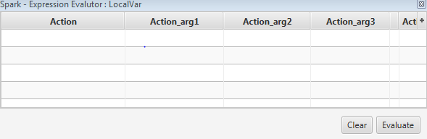

11.5 Sheet View
Sheet view has four tabs and each represents the worksheet of the test suite file.
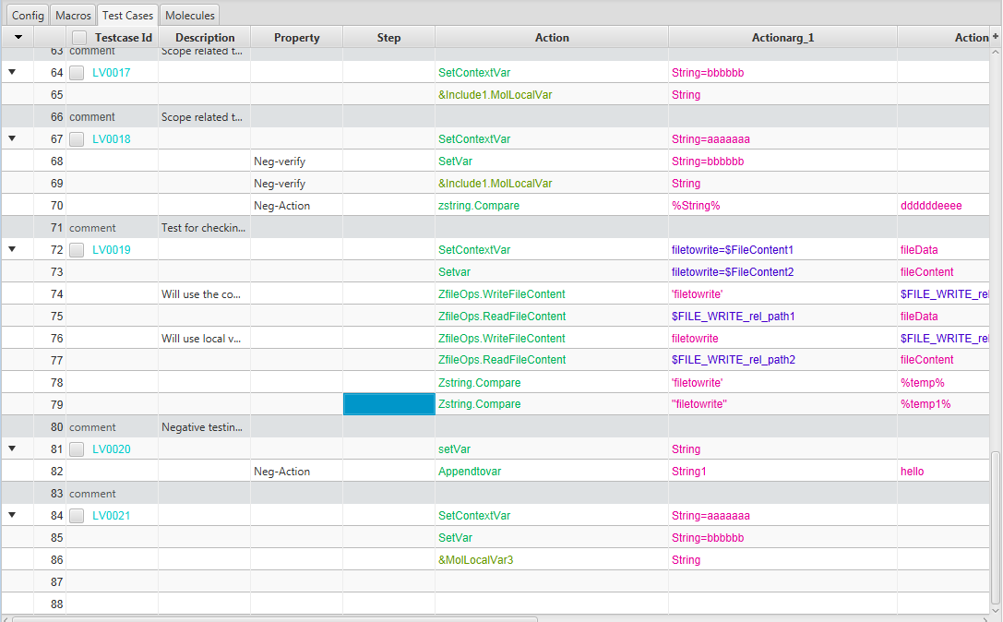

We can hover on action and verification column to view the signature of the atoms and molecules.
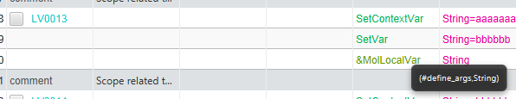
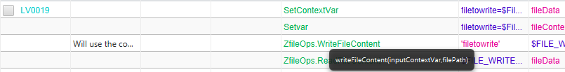

If Spark is not able to find the molecule or the atom it changes the color of the text and underlines it. On hovering on that cell gives the error message as shown below.
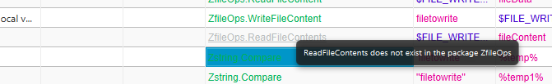

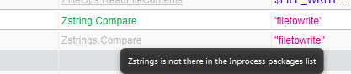

If arguments column contains a macro then on the tooltip its value is shown.
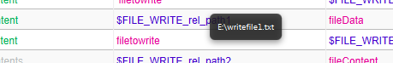

11.6 Navigating sheets :

11.6.1 Navigating Molecules :

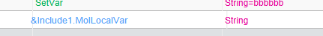
We can directly go to the molecule definition through molecule call by pressing Ctrl key and clicking on the molecule name. As soon as we click that molecule will be opened in the sheet view and it will be expanded.

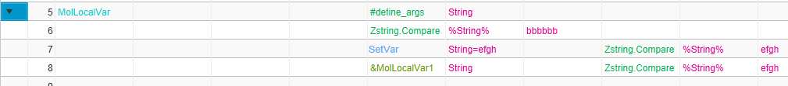

11.6.2 Navigating Different Sheets
If a test suite is including sheets then we can view those sheets in the Linked files window in side bar.
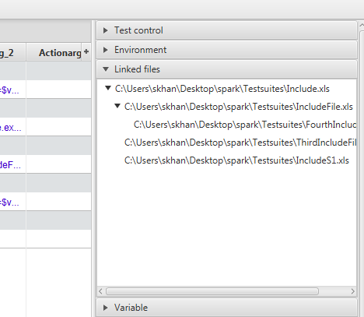
It shows the Linked files in the hierarchy in which they are included
(tree like structure).We can click on any of of the files listed here to open it in the sheet view.

11.7 Editing and Saving sheets

11.7.1 Editing Sheet
We can double click on any cell of a sheet and edit its value.
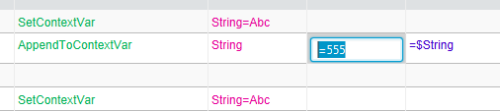
1.Double click on the cell.

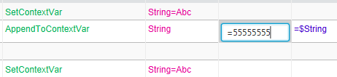
2.Edit its value.

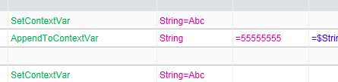
3.
a)Press Enter to keep the changes

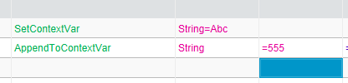
b)Press Esc to skip the changes.

11.7.2 Saving sheet
Click on save in file menu to save changes that you have made in the sheet view to the test suite file in the disk.

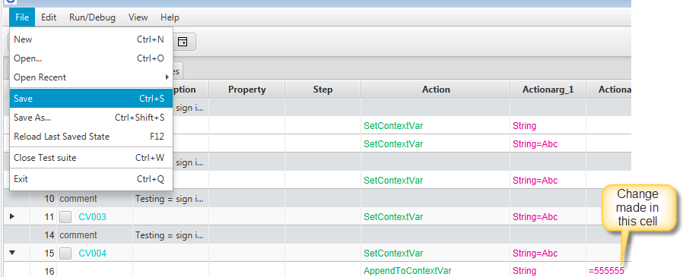
Now if you open the test suite file using MS-Excel or open office you will be able to see the changes that you have made.
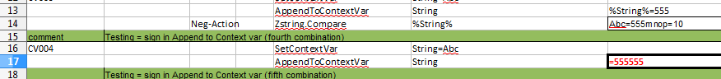

You can also save the test suite file with different name using Save as option in the file menu.

Reverting to old state:
If there are unsaved changes that have been made in the sheet view and you don't want to save it and want to work with the old copy of your test suite you can use the Reload Last Saved State in the file menu. It will restore sheet view to the last working copy .

12 Troubles hooting.
If you get the below error message while launching Spark. Then you either don't have Java 8 installed or it is not you default java. Install Java 8 .If you have Java 8 then either make Java 8 your default java or follow the steps below.
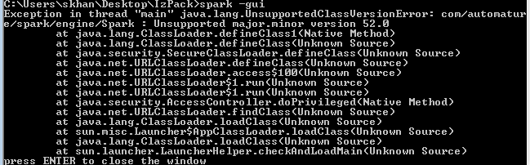
- Copy the Java 8 location up to bin folder.
- Go to the SPARK installation folder.
- Append java location path in Spark launch file.
  - In windows spark.bat
  - In mac and linux spark

Example:


